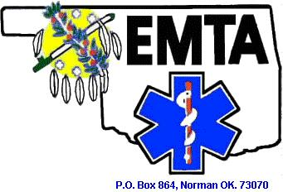

[**http://www.oemta.org**](http://www.oemta.org)

**11th Annual Member/Vendor Medic Update Golf Tournament**

**4 Person Scramble**

**WHEN: Tuesday --- July 25, 2017**

**WHERE: Westwood Park Golf Course, 5 minutes or so from Convention Center**

**2400 Westport Drive in Norman, OK.**

**TEE TIME: 10:00 AM – Registration from 9:00 to 10:00**

**Put together your own team, or let me know what your handicap is, if you know it, and I will put you on a team, remember this is for fun and fellowship, and do some networking with your fellow EMT’s and Vendors.**

***PLEASE RSVP ASAP*, as I have to personally sign a guarantee contract two weeks before our event, so that we can plan accordingly to make this a fun event for everyone**

**COST: $42.42 per person**

**This covers green fees and cart per person**

**For More Information Or To Enter Your Team Please Contact:**

**Bill Greenfield @ 806-339-4646 or** [**bubbatexokie@gmail.com**](mailto:bubbatexokie@gmail.com)

**j0078800**

***HOLE SPONSORSHIPS ARE AVAILABLE --- PLEASE CONTACT ME FOR MORE INFO***

**BRONZE - $50.00**

**SILVER - $100.00**

**GOLD - $150.00**

**PLATINUM - $200.00**